Formulas & functions

Create formulas
Get started on how to create formulas and use built-in functions to perform calculations and solve problems.
Formula bar
- When a formula is entered into a cell, it also appears in the Formula bar.
Create a formula that refers to values in other cells
- Select a cell.
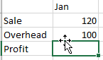
- Type the equal sign =.
Note: Formulas in Excel always begin with the equal sign.
- Select a cell or type its address in the selected cell.
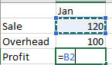
- Enter an operator. For example, – for subtraction.
- Select the next cell, or type its address in the selected cell.
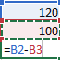
- Press Enter. The result of the calculation appears in the cell with the formula.
To see a formula
- Select a cell, and see the formula in the formula bar.
Enter a formula that contains a built-in function
- Select an empty cell.
- Type an equal sign = and then type a function. For example, =SUM for getting the total sales.
- Type an opening parenthesis (.
- Select the range of cells, and then type a closing parenthesis).
- Press Enter to get the result.
Relative references
- A relative cell reference in a formula, such as B2:G2, is based on the relative position of the cell that contains the formula, such as H2. If the position of the cell that contains the formula changes, the reference is changed. If you copy or fill a formula across rows or down columns, the reference automatically adjusts. By default, new formulas use relative references. For example, if the formula in H2 is copied to H3, it automatically adjusts from =SUM (B2:G2) to =SUM (B3:G3).

SUM
Add values in Excel with the SUM function. You can add individual values, cell references, ranges, or a mix of all three.
For example:
- =SUM (A2:A10)
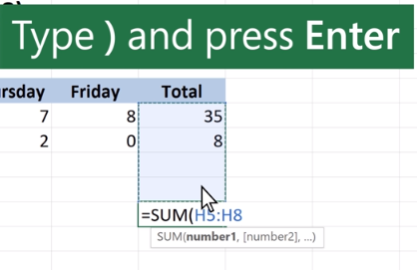
- =SUM (A2:A10, C2:C10)
Use the SUM function
- Select a cell.s
- Type =SUM (
- Select the cells you want to add.
- Type a closed parenthesis) and press Enter.

IF
Use IF to return a value based on a condition.
- Select a cell.
- Type =IF.
- Add the condition you want to test.
- Add the value to return if the condition is true.
- Add the value to return if the condition is false.
- Press Enter.
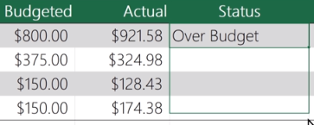
- If needed, drag the handle to apply the IF function to other rows.
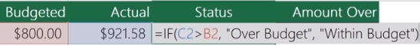

Subtraction
Subtract values in Excel using the minus sign (-). You can subtract cells, individual values, or a mix.
For example:
- =A9-A10
- =50-30
- =H9-20
Subtract in Excel
- Select a cell.
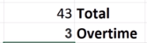
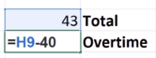
- Type =.
- Type a number or select a cell.
- Type a minus sign (-).
- Type a number or select a cell to subtract.
- Press Enter.

Multiplication
Multiply values in Excel using an asterisk (*). You can multiply cells, individual values, or a mix.
For example:
- =A9*A10
- =50*30
- =H9*20
Multiply in Excel
- Select a cell.
- Type =.
- Type a number or select a cell.
- Type an asterisk (*).
- Type a number or select a cell to multiply by.
- Press Enter.

Division
Divide values in Excel using a forward slash (/). You can divide cells, individual values, or a mix.
For example:
- =A9/A10
- =50/10
- =H9/2
Divide in Excel
- Select a cell.
- Type =
- Type a number or select a cell.
- Type a forward slash (/).
- Type a number or select a cell to divide by.
- Press Enter.

